WEEK-5 ASSINMENT
Q1: What are the key limitations of traditional MapReduce that make Spark a prefechoice for modern big data processing?
Answer – Limitations of Traditional MapReduce:
Writes intermediate data to disk after every stage, making it slower.
Not suitable for iterative algorithms like Machine Learning.
High latencyfor real-time processing.
Complex programming model with separate Map and Reduce phases.
Inefficient for interactive analytics.

Q2: Explain how Spark uses In-Memory Computing to speed up iterative machine learning algorithms compared to disk-based systems.
Answer – Spark stores intermediate data in RAM instead of writing it to disk after every computation. Since machine learning algorithms repeatedly process the same data over multiple iterations, keeping data in memory eliminates repeated disk I/O operations, resulting in much faster execution than MapReduce

Dataset Used :
Created A synthetic Retail sales dataset consisting of 10,000 Records Using LLM . It is created to simulate Real world Data. The Dataset designed contains Impurities In order to perform Cleaning operations.
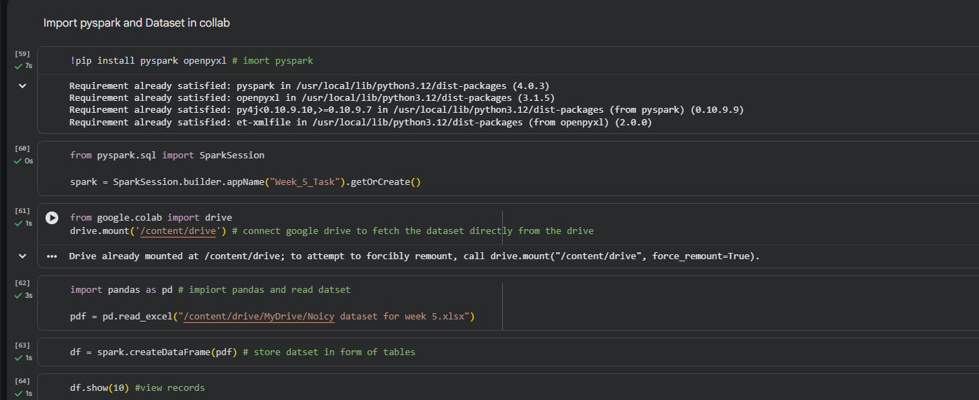
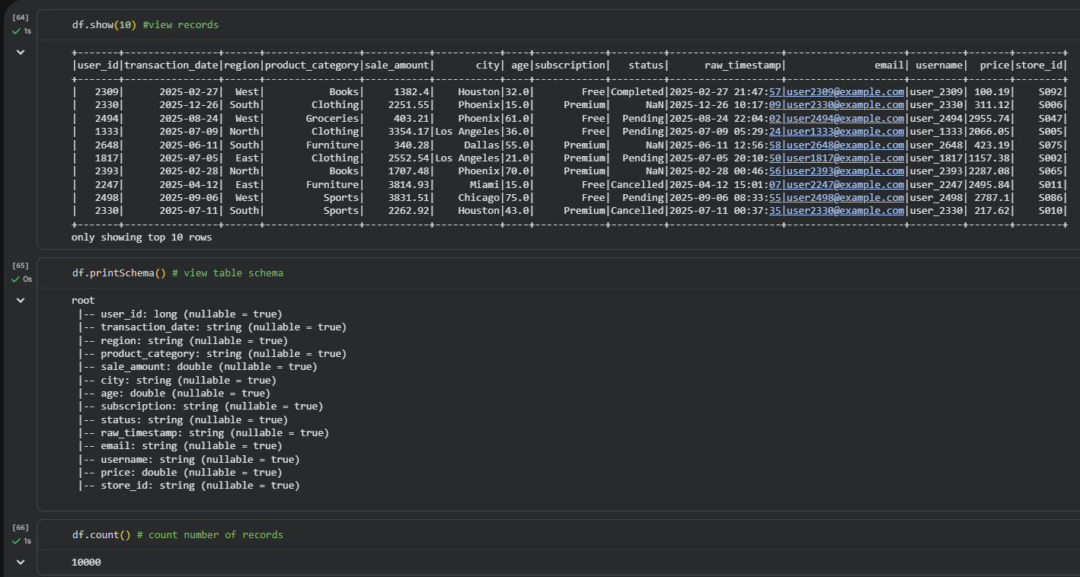

Q3: Write a code snippet to remove all duplicate rows from a DataFrame based on a specific set of columns: user_id and transaction_date.
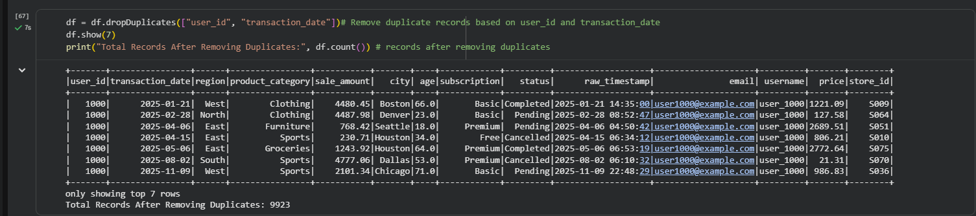
Q4: Given a DataFrame df_sales, write a query to filter for rows where the region is 'West' and then group by product_category to find the average sale_amount.
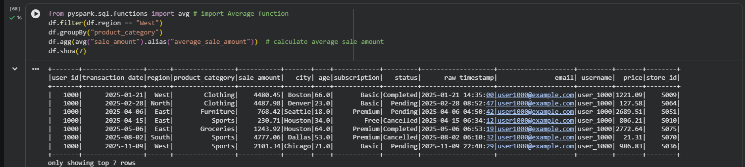
Q5: What is the difference between .na.drop() and .na.fill()? Provide a code example of filling null values in a status column with the string 'Unknown'.
Theory : .na.drop() - Removes rows containing null values.
.na.fill() - Replaces null values with specified values.
Code :
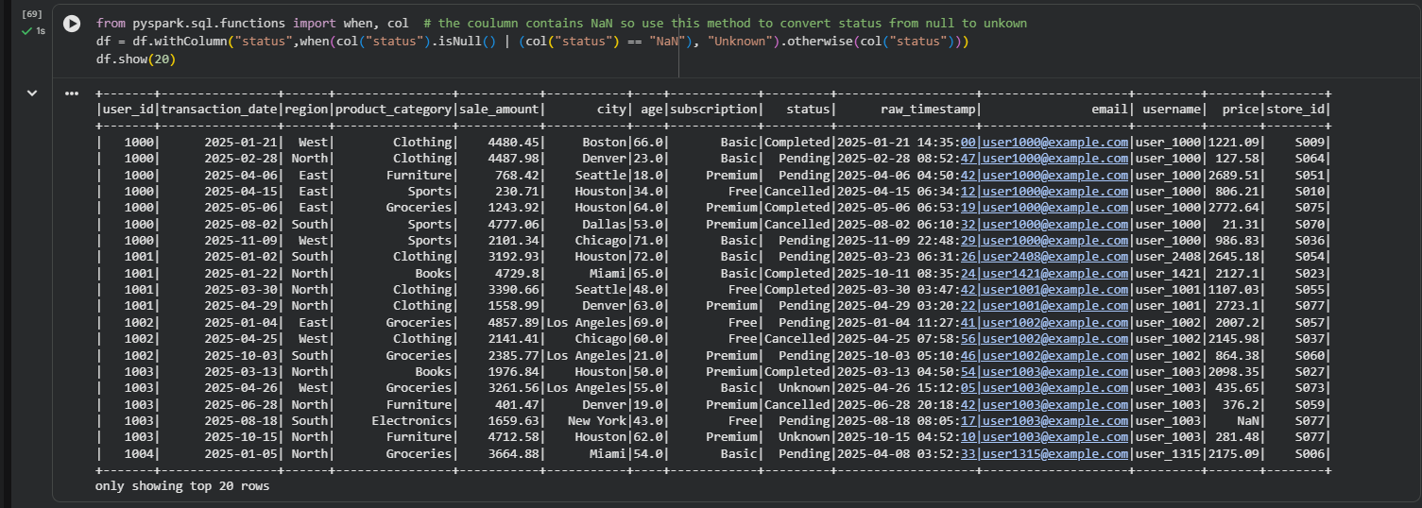
Q6: Write a query to find the total count of records for each city in a DataFrame, but only for cities where the count is greater than 100.
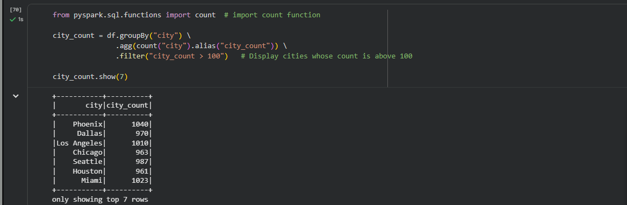
Q7: How does the immutability of Spark DataFrames affect how you perform "data cleaning" steps like dropping columns or renaming them?
Theory: Spark DataFrames are immutable, meaning they cannot be modified directly. Every operation such as dropping columns, renaming columns, or filtering data creates a new DataFrame rather than changing the existing one. Therefore, the result must be assigned to a new or the same variable.
Code:
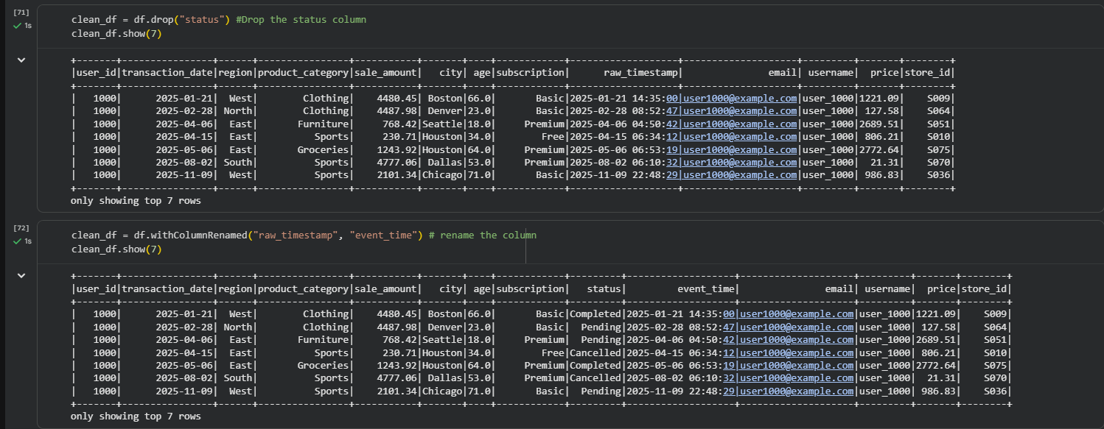

Q8: Write a Spark command to filter a dataset for rows where the age is between 18 and 30 (inclusive) and the subscription is 'Premium'.
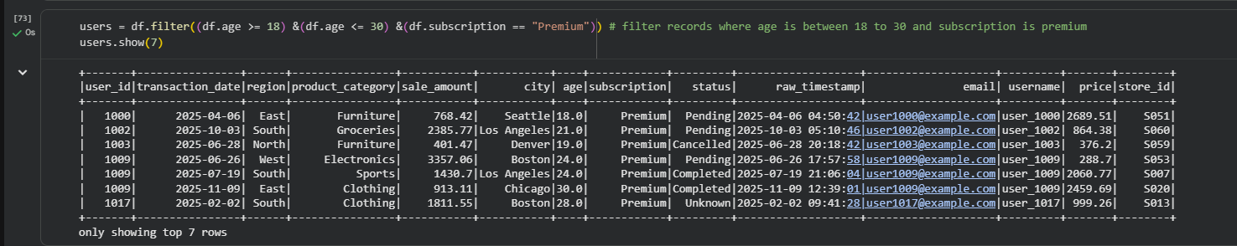
Q9: When cleaning a dataset, why is it often better to handle null values before performing mathematical aggregations like sum() or avg()?
Theory : Handling null values before performing calculations ensures accurate results. Null values may cause incorrect average, missing total, or unexpected output. By Filling or removing null values we can improves data quality and prevents misleading analysis.
Code:
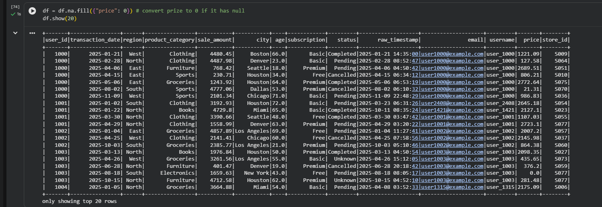

Q10: Write the code to revise a column named raw_timestamp by casting it to a TimestampType and renaming it to event_time.
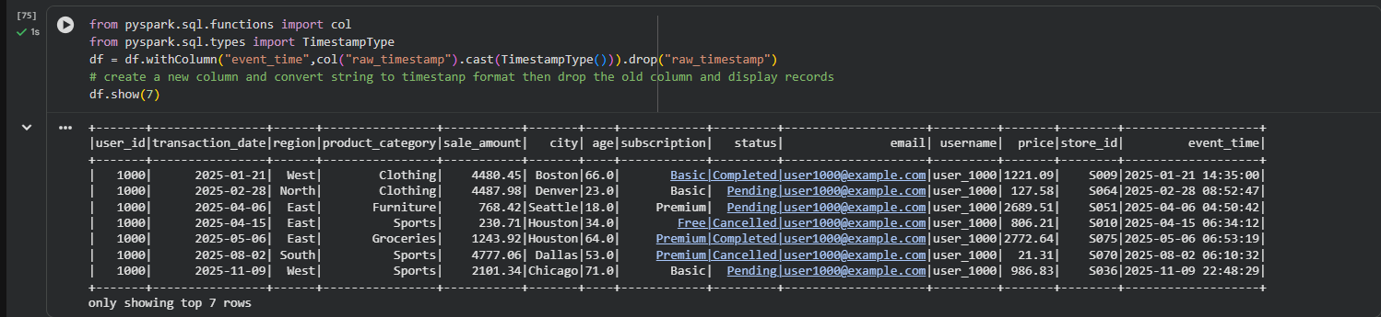
Q11: Explain the "Shuffle" process that occurs during a grouping operation. Why is it considered a wide transformation?
Theory : Shuffle is the process of redistributing data across different partitions during operations like groupBy(), join(), and reduceByKey().
Code :
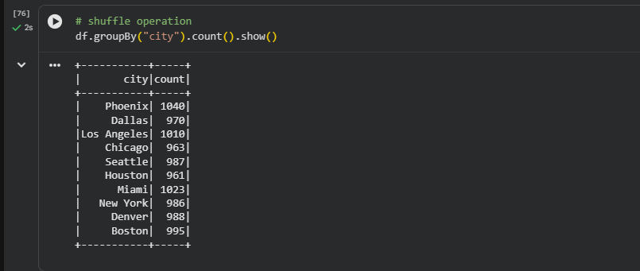

Q12: Write a code snippet that identifies and removes rows where the email column contains null values OR the username is an empty string.
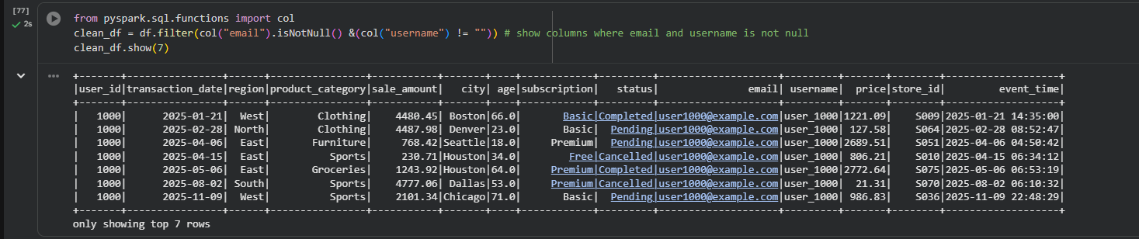
Q13: How do you use the .agg() function to calculate multiple statistics at once, such as the min, max, and mean of the price column?
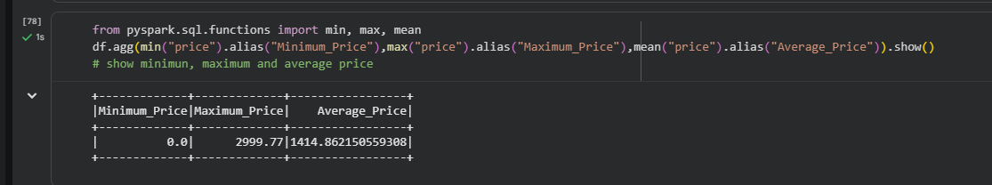

Q14: In the context of cleaning a dataset, what is the risk of using inferSchema=true when your source data contains messy or inconsistent date formats?
Answer : When date formats are inconsistent, “inferSchema=True” may incorrectly identify the column type as String or infer incorrect data types. This can lead to parsing errors, incorrect sorting, failed date calculations, and inaccurate analysis. It is generally safer to specify the schema explicitly for messy datasets.

Q15: Write a final processing pipeline that:
- Filters out duplicates.
- Fills null prices with 0.
- Groups by store_id to calculate total revenue.

